**Practical No. 14**

**//Perform the Steps to Create Page in Drupal.**

Step 1- Login in WordPress Administrator (Node)

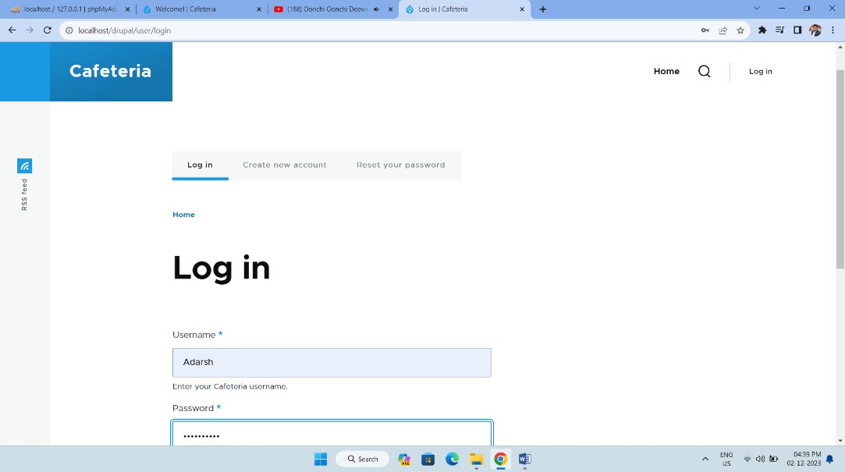

Step 2 - Select Content option and add new Content

Content > Add content > Basic page (node/add/page).

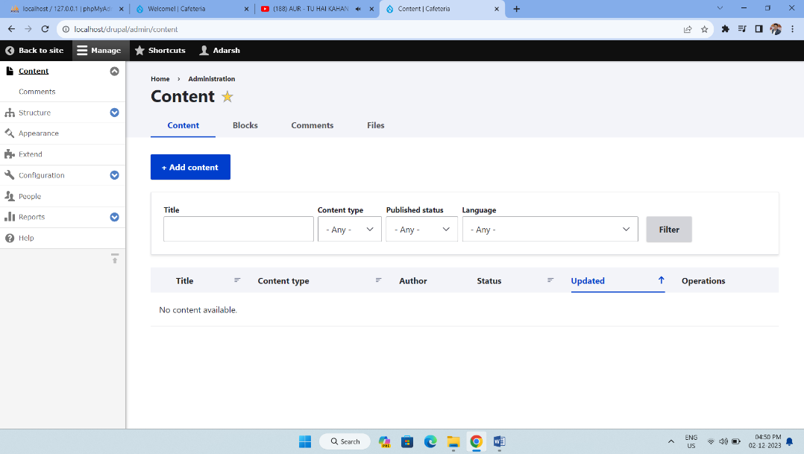

Step 3 - The Create Basic page form appears.

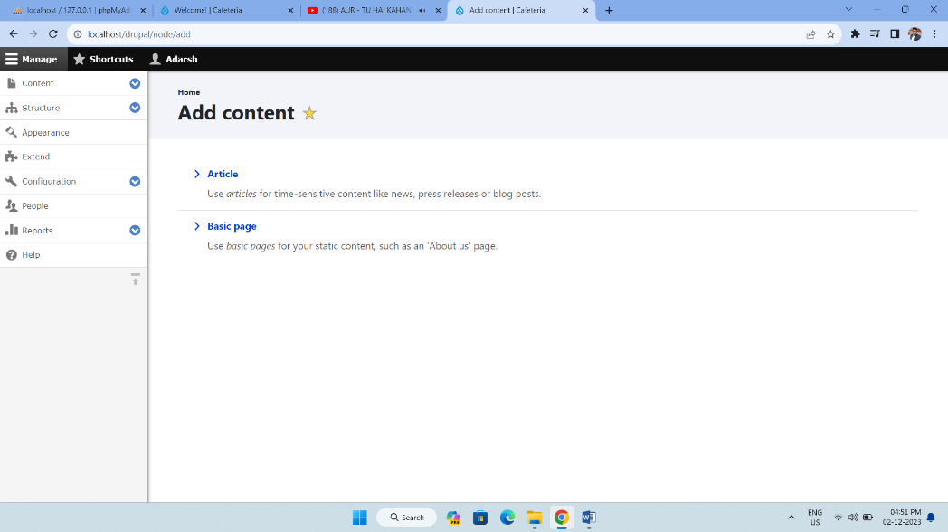

Step 4 - To add text, you just click and type.

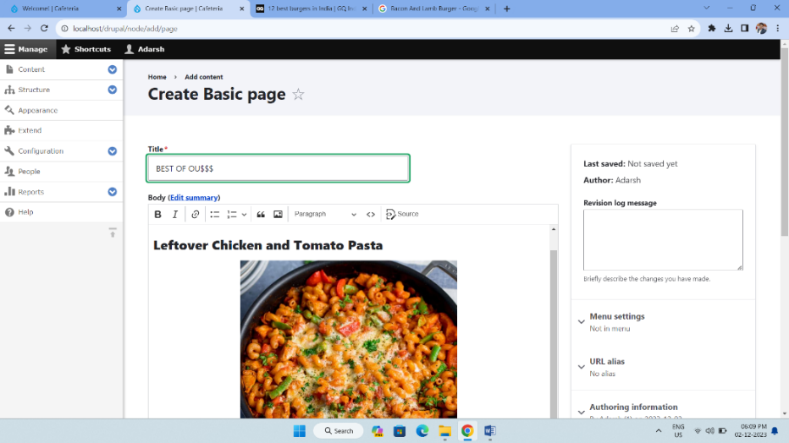

Step 5 - Front End (Content Created, Modified, Published)

